Chlamydia Among College Students in the United States

Lateese M. Perry
California State University of Long Beach
HSC 400: Principles of Epidemiology
Binh Goldstein
March 22, 2024

The Problem: Chlamydia Among College Students in the United States
Chlamydia trachomatis (C. trachomatis), an obligate intracellular bacterial parasite, causes the most commonly diagnosed sexually transmitted bacterial infection worldwide (Niu et al., 2023). Due to their asymptomatic nature, chlamydia infections pose a significant public health threat among college students and continue to remain a prevalent issue on campuses in the United States. This analysis explores the global health implications of Chlamydia, including epidemiological variables, control methods, knowledge gaps, and future research opportunities.
Extent of the Problem
Mortality. Chlamydia itself rarely causes mortality directly. Mortality rates associated with Chlamydia are generally low but can vary depending on factors such as access to healthcare, quality of treatment, and the presence of comorbidities.
Morbidity. Chlamydia is one of the most prevalent STIs globally, with millions of new cases reported each year, as displayed in Appendix A. In 2022, a total of 1,649,716 cases of Chlamydia trachomatis infection were reported, making it the most common nationally notifiable sexually transmitted infection in the United States for that year (Centers for Disease Control and Prevention [CDC], 2024). As portrayed in Appendix A, the highest prevalence of STIs is among college-aged students, with approximately two-thirds of students reporting having sex in the last year (Johnson & Jackson, 2021).
Economic Impact. Overall, Chlamydia and gonorrhea are estimated to cost the United States almost $1 billion annually in direct medical costs, including costs of treating infections and sequelae costs of untreated or inadequately treated infections (Kumar et al., 2020). Healthcare costs related to Chlamydia include expenses for testing, treatment, and management, which can burden healthcare systems and individual finances. Further, it can lead to productivity loss due to symptoms interfering with work or school attendance, long-term disability, and personal costs such as stigma and psychological distress, indirectly impacting an individual's well-being and ability to participate in the workforce.
Agent of Disease
Chlamydia trachomatis (C. trachomatis) is an important gram-negative obligate intracellular bacterium and belongs to the genus Chlamydia (phylum Chlamydiae, order Chlamydiales, family Chlamydiaceae) together with Chlamydia muridarum and Chlamydia suis, (Niu et al., 2023), and can be seen in Appendix C. When exposed to the bacterium and symptoms develop, the incubation period for Chlamydia typically ranges from 1 to 3 weeks.
Conditions and Clinical Symptoms
Symptoms of Chlamydia can appear in people of all genders (Planned Parenthood, n.d.). Infections can present with a variety of symptoms, such as genital discomfort, pain, burning during urination, abnormal genital discharge, itching, and discomfort during sexual intercourse. “C. trachomatis can lead to many urogenital infections, including cervicitis, pelvic inflammatory disease, urethritis, epididymitis, prostatitis, and lymphogranuloma venereum. Extragenital infections caused by C. trachomatis include conjunctivitis, perihepatitis, pharyngitis, reactive arthritis, and proctitis” (Mohseni et al., 2023).
Modes of Transmission
The bacterium is transmitted through direct contact with infected tissue, including vaginal, anal, or oral sex, as displayed in Appendix D. It can even be passed from an infected mother to the newborn during childbirth (Mohseni et al., 2023). Due to the high prevalence of asymptomatic infections, individuals may unknowingly transmit the infection to sexual partners.
Mechanisms of Control
Primary. Primary prevention strategies for chlamydia focus on promoting sexual education and health awareness. This includes using condoms consistently and correctly, getting regular screenings, and practicing abstinence or monogamy (CDC, 2023). These measures aim to reduce the risk of transmission, facilitate early detection and treatment, and prevent new infections. Ultimately, abiding by these measures will improve sexual health outcomes and reduce the burden of Chlamydia on individuals and communities.
Secondary. Secondary prevention involves early detection of at-risk populations such as sexually active individuals under the age of 25 or those with multiple sex partners. Prompt antibiotic treatment can prevent complications such as pelvic inflammatory disease or infertility (American College of Obstetricians and Gynecologists [ACOG], 2023).
Tertiary. Tertiary prevention focuses on managing and reducing the long-term sequelae and complications of the infection who have already experienced adverse outcomes. This may involve ongoing medical care, monitoring, and treatment to address complications such as chronic pelvic pain, infertility, and ectopic pregnancy in women or epididymitis and reactive arthritis in men. Prevention efforts aim to provide supportive services and resources to improve individuals' quality of life and overall well-being, including partner notification, follow-up testing, and education on preventing reinfection (World Health Organization [WHO], 2019).
Factors of Vulnerability
Host factors. Host factors affecting chlamydia infection include age, with sexually active young adults being particularly susceptible, and gender, as women are more prone to complications. The overall rate of urogenital infection amongst U.S. women is two times that of U.S. men, with a higher prevalence in women 15-24 years of age and a higher incidence in men between 20-24 years of age (Mohseni et al., 2023). While the infection is curable in 95% of cases with antibiotics, C. trachomatis has evolved mechanisms to avoid destruction by autophagy and the host immune system and to persist within host cells (Niu et al., 2023).
Environmental factors. The environmental factors contributing to chlamydia transmission among college students include the social dynamics of campus life, which often involve a high prevalence of sexual activity and frequent partner turnover. A routine screening for Chlamydia on 10 college campuses found the prevalence of Chlamydia among college students was 9.7% (Johnson & Jackson, 2021). Moreover, the presence of stigma surrounding STIs may also discourage some students from seeking testing or disclosing their infection status.
Socioeconomic factors. In college settings, socioeconomic factors can affect chlamydia prevalence, as students from lower-income backgrounds may encounter challenges accessing health services due to financial constraints. There is a clear association between low SES and the risk of getting an STI (Boskey, 2022).
Epidemiological Variables
Temporal variation. Chlamydia is sometimes called the “Silent Epidemic” because it causes immense damage to numerous people without showing any symptoms (TeenSource, n.d.). Factors like academic schedules, social events, and changes in student populations can influence its spread on college campuses. For instance, chlamydia incidence rates may fluctuate during peak periods of student activity, like the start and end of semesters, or during major events like spring break.
Racial Disparities. Appendix E displays the disparities in Chlamydia rates among different racial and ethnic groups, with some populations experiencing higher rates of infection compared to others. Understanding the role of race in chlamydia epidemiology can help identify at-risk populations and address underlying social determinants of health to reduce disparities in chlamydia burden and promote health equity.
Conclusion
Current Hypothesis
One current hypothesis regarding Chlamydia in U.S. colleges and students focuses on the intersection of social and environmental factors with individual behaviors (Chin Quee, 2023). It posits that high rates of Chlamydia among college students may be influenced by factors such as the prevalence of casual sexual encounters, inconsistent condom use, and limited access to sexual health resources on campuses. Additionally, social norms and peer influences within college environments may contribute to increased sexual risk-taking behaviors.
Gaps in Knowledge
Gaps in knowledge regarding Chlamydia among college students include understanding the specific risk factors contributing to transmission within campus environments, such as the impact of social networks, living arrangements, and sexual behavior patterns. A lack of chlamydia knowledge in this high‐risk group likely contributes to decreased testing, but interventions to increase chlamydia knowledge in this population are not well‐described in the literature (Russell et al., 2022).
Areas for Further Research
Chlamydia Vaccine. While the development of a chlamydia vaccine is being actively pursued, understanding the optimal vaccine formulation, dosing regimen, and immunization schedules to achieve long-lasting protection against infection is fundamental; however, no commercial vaccine is yet available to treat the C. trachomatis infection (Aslam et al., 2021).
Therefore, further research is necessary to address this issue effectively in future populations.
References
American College of Obstetricians and Gynecologists. (2023, January). Chlamydia, gonorrhea, and syphilis. ACOG. https://www.acog.org/womens-health/faqs/chlamydia-gonorrhea-and-syphilis
Aslam, M., Shehroz, M., Ali, F., Zia, A., Pervaiz, S., Shah, M., Hussain, Z., Nishan, U., Zaman, A., Afridi, S. G., & Khan, A. (2021). Chlamydia trachomatis core genome data mining for promising novel drug targets and chimeric vaccine candidates identification. Computers in Biology and Medicine, 136, 104701. https://doi.org/10.1016/j.compbiomed.2021.104701
Boskey, E. (2022, April 20). Socioeconomic status affects individual health. Verywell Health. https://www.verywellhealth.com/socioeconomic-status-ses-3132909
Bottaro, A. (2022, August 15). Everything you should know about Chlamydia. Verywell Health. https://www.verywellhealth.com/chlamydia-facts-and-statistics-5443056#citation-1
Centers for Disease Control and Prevention. (2023, February 22). Prevention - STD information from CDC. Centers for Disease Control and Prevention. https://www.cdc.gov/std/prevention/default.htm
Centers for Disease Control and Prevention. (2024, January 30). National Overview of STIs, 2022. Centers for Disease Control and Prevention. https://www.cdc.gov/std/statistics/2022/overview.htm#:~:text=In%202022%2C%20a%20total%20of,2021%20(495.5%20per%20100%2C000).
Chin Quee, Jessie E., "Using Wastewater-Based Epidemiology to Study Chlamydia Occurrence on a College Campus" (2023). Honors Undergraduate Theses
Cleveland Cinic. (2023, February 6). Chlamydia: Causes, symptoms, treatment & prevention. Cleveland Clinic. https://my.clevelandclinic.org/health/diseases/4023-chlamydia
Johnson, A., & Jackson, J. (2021). Sexually transmitted infections among college students. Microbiology &amp; Infectious Diseases, 5(1). https://doi.org/10.33425/2639-9458.1107
Kumar, S., Chesson, H., & Gift, T. L. (2020). Estimating the direct medical costs and productivity loss of outpatient chlamydia and gonorrhea treatment. Sexually Transmitted Diseases, 48(2). https://doi.org/10.1097/olq.0000000000001240
Mohseni, M., Sung, S., & Takov, V. (2023, August 8). Chlamydia. StatPearls [Internet]. https://www.ncbi.nlm.nih.gov/books/NBK537286/
Niu, S., Huang, S., & Liu, B. (2023). Chlamydia trachomatis. Molecular Medical Microbiology, 1343–1356. https://doi.org/10.1016/b978-0-12-818619-0.00049-6
Planned Parenthood Federation of America Inc. (n.d.). What are the symptoms & signs of Chlamydia?. Planned Parenthood. https://www.plannedparenthood.org/learn/stds-hiv-safer-sex/chlamydia/chlamydia-symptoms
Russell, N. G., Sharps, P. W., & Sloand, E. (2022). Web-based chlamydia education for university students: A pilot project. Nursing Open, 9(5), 2342–2347. https://doi.org/10.1002/nop2.1244
TeenSource. (n.d.). Chlamydia symptoms in men & women, treatment options. TeenSource. https://www.teensource.org/std/chlamydia
World Health Organization. (2023, July 17). Chlamydia. World Health Organization. https://www.who.int/news-room/fact-sheets/detail/chlamydia

Appendix A
World Health Organization [WHO], (2023): Global and regional STI estimates:
Chlamydia in adults
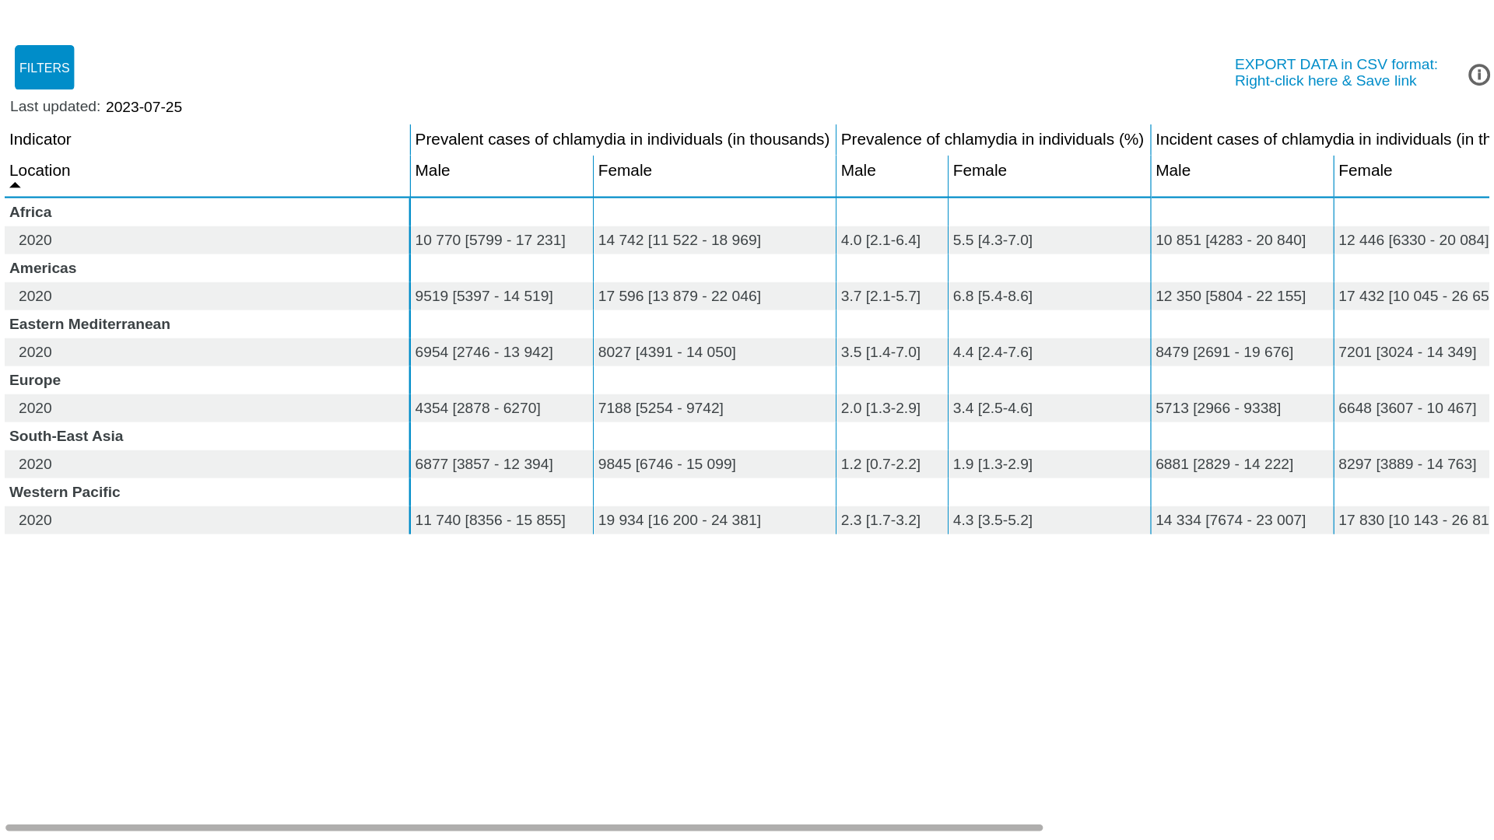

World Health Organization [WHO], 2023.
https://www.who.int/data/gho/data/themes/topics/global-and-regional-sti-estimates

Appendix B
Centers for Disease Control and Prevention [CDC] (2024) : Chlamydia — Rates of
Reported Cases by Age Group and Sex, United States, 2022

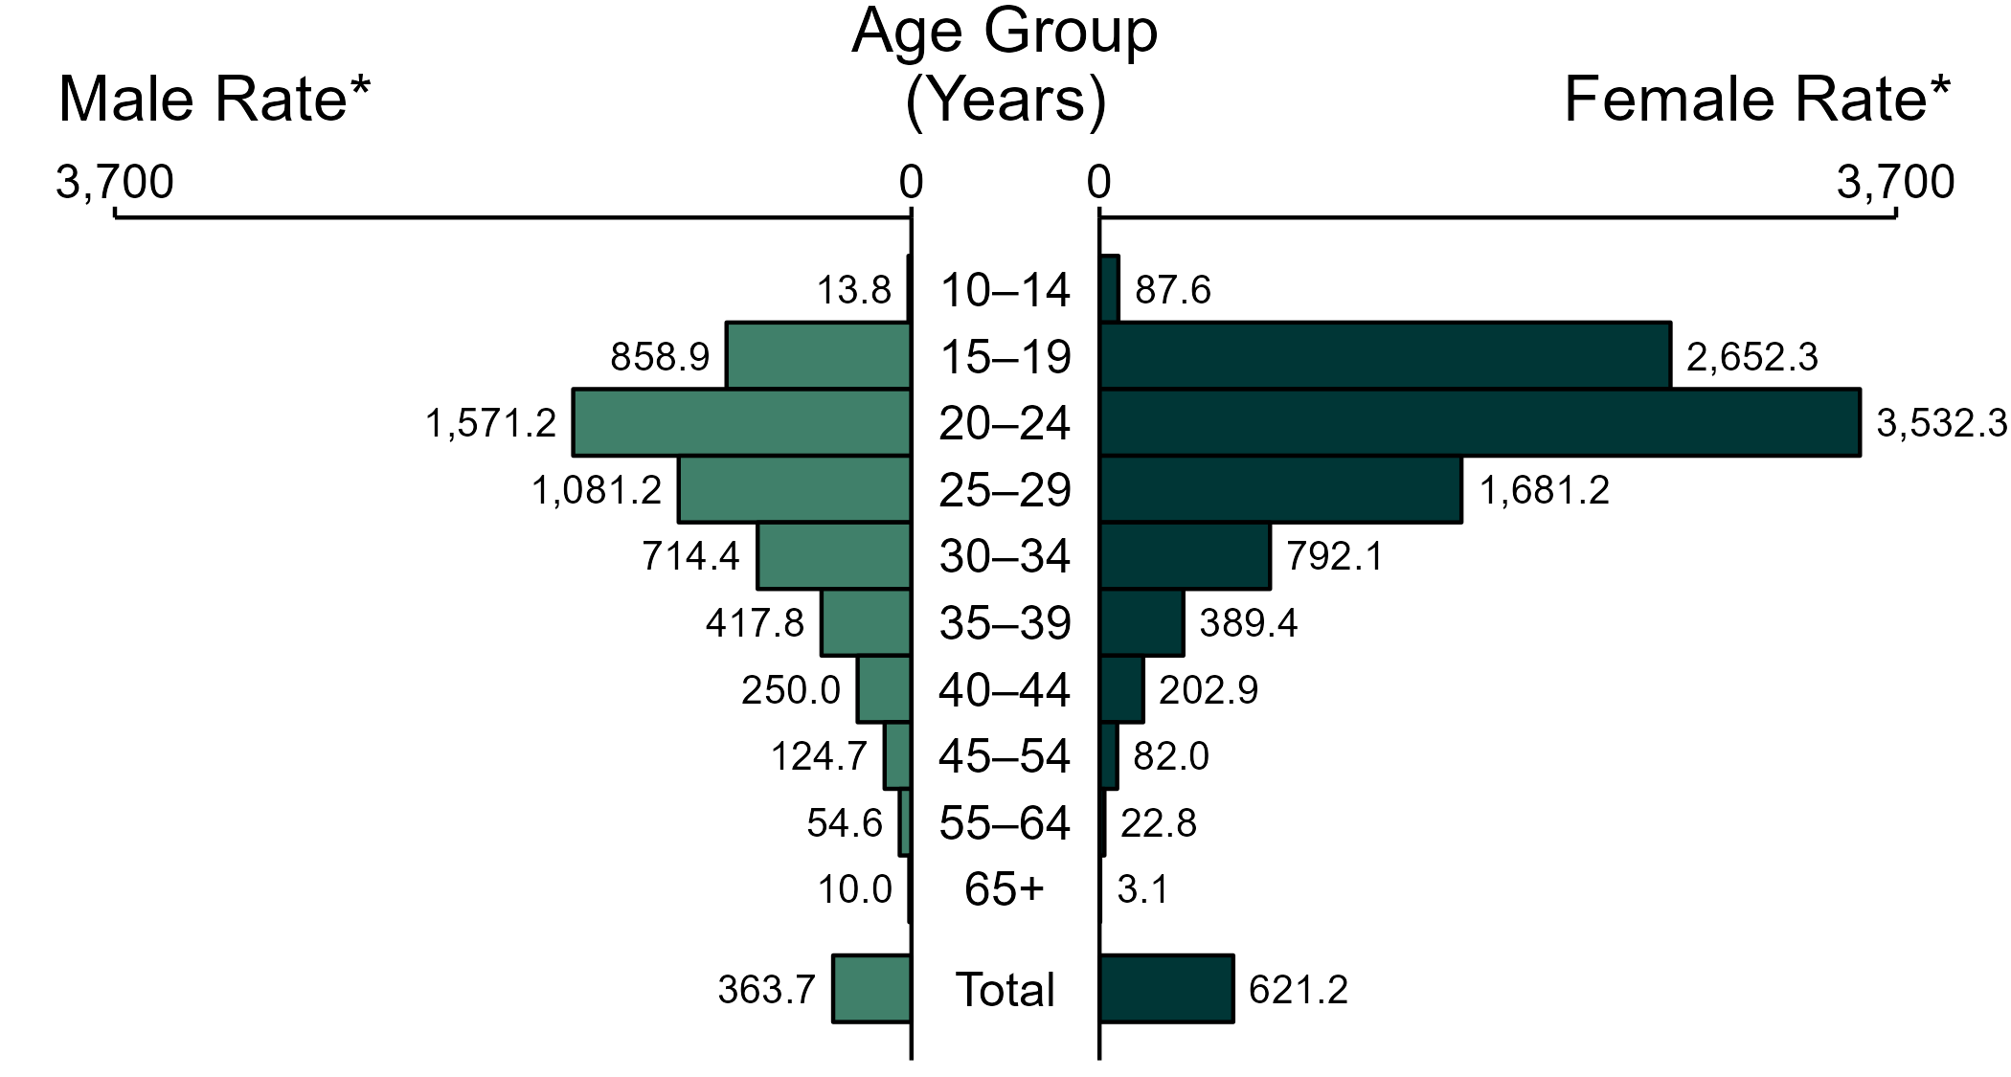
(Centers for Disease Control and Prevention [CDC], 2024).
https://www.cdc.gov/std/statistics/2022/figures/ct-2.htm#print

Appendix C
Chlamydia; sexually transmitted disease
A Pap smear specimen showing the bacterium Chlamydia trachomatis, the cause of the sexually transmitted disease chlamydia. (Bacteria appear within vacuoles.)
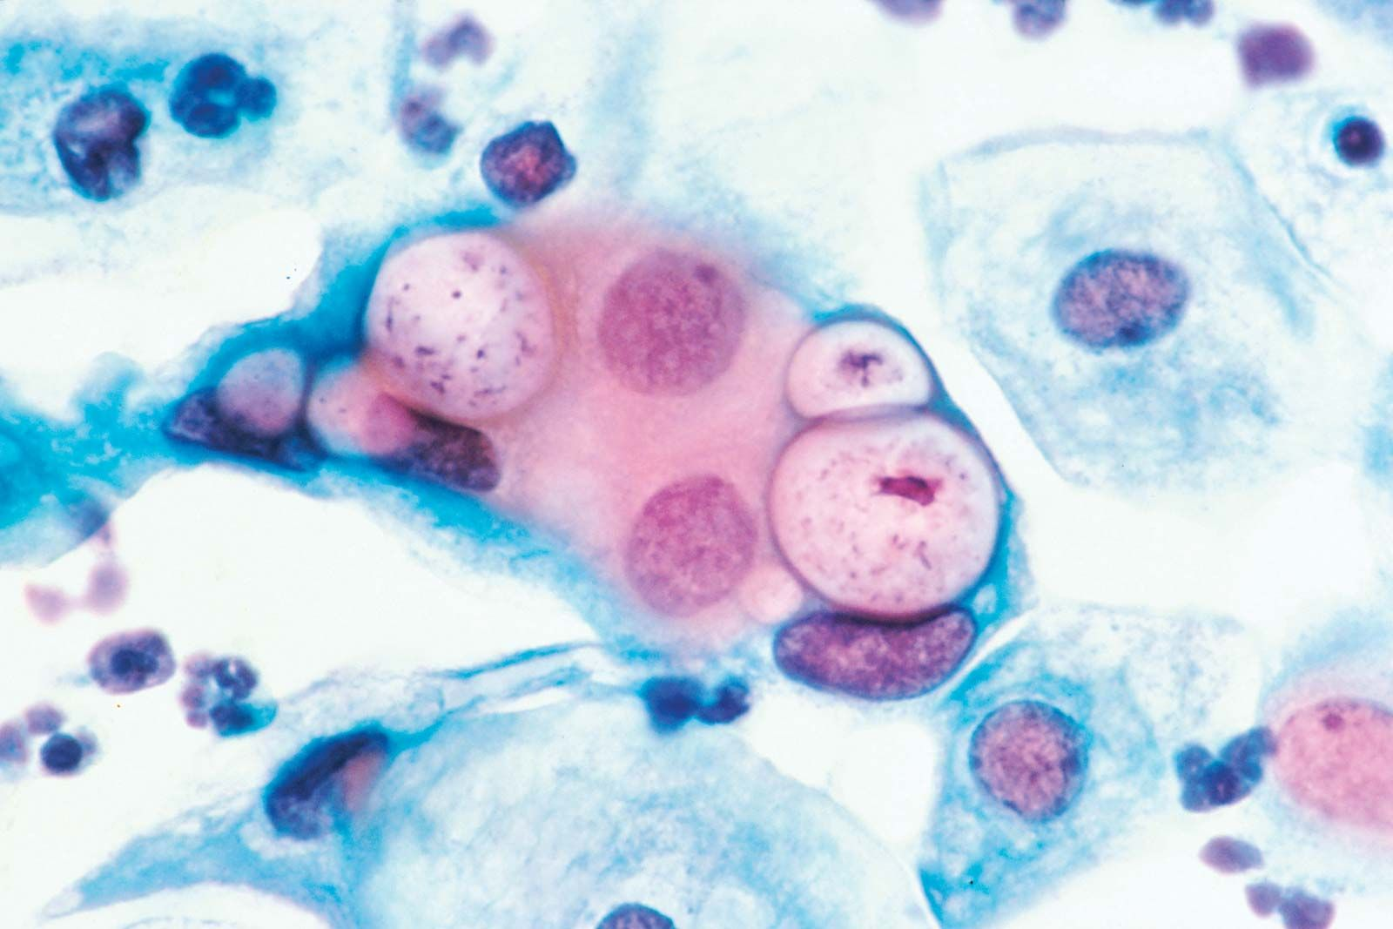

Britannica, T. Editors of Encyclopaedia (2023, October 3). Chlamydia. Encyclopedia Britannica.
https://www.britannica.com/science/Chlamydia-microorganism

Appendix D
Medicover Hospitals (n.d.): Chlamydia Life Cycle
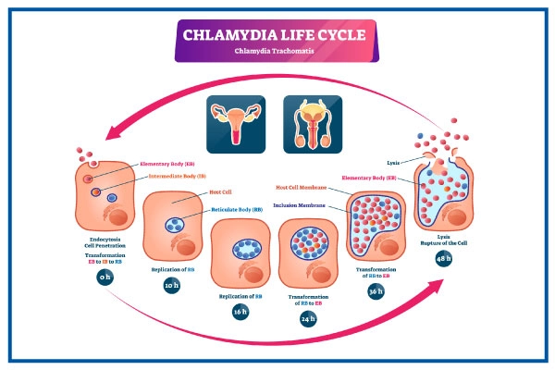
(Medicover Hospitals, n.d.)
https://www.medicoverhospitals.in/diseases/chlamydia-infection/

Appendix E
Statista (2024): Rates of reported cases of Chlamydia in the United States in 2022, by race/ethnicity and gender (per 100,000 population)
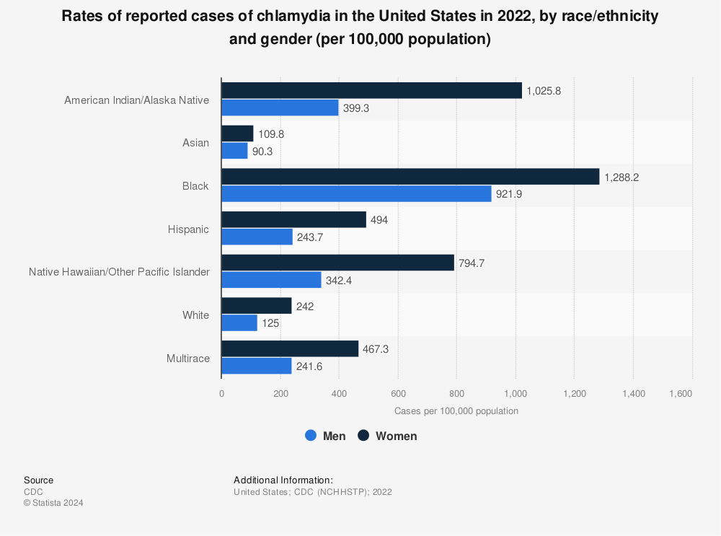

(John Elflein, 2024). Chlamydia rates in the United States 2022, by race/ethnicity and gender.
https://www.statista.com/statistics/622891/chlamydia-rates-in-the-us-by-ethnicity-and-gender/

